SOME SNAPSHOT OF THE ASSISGNMENT.

Figure . Created README.txt and created branch name html-assignment and created file of HTML-Assignment on that branch

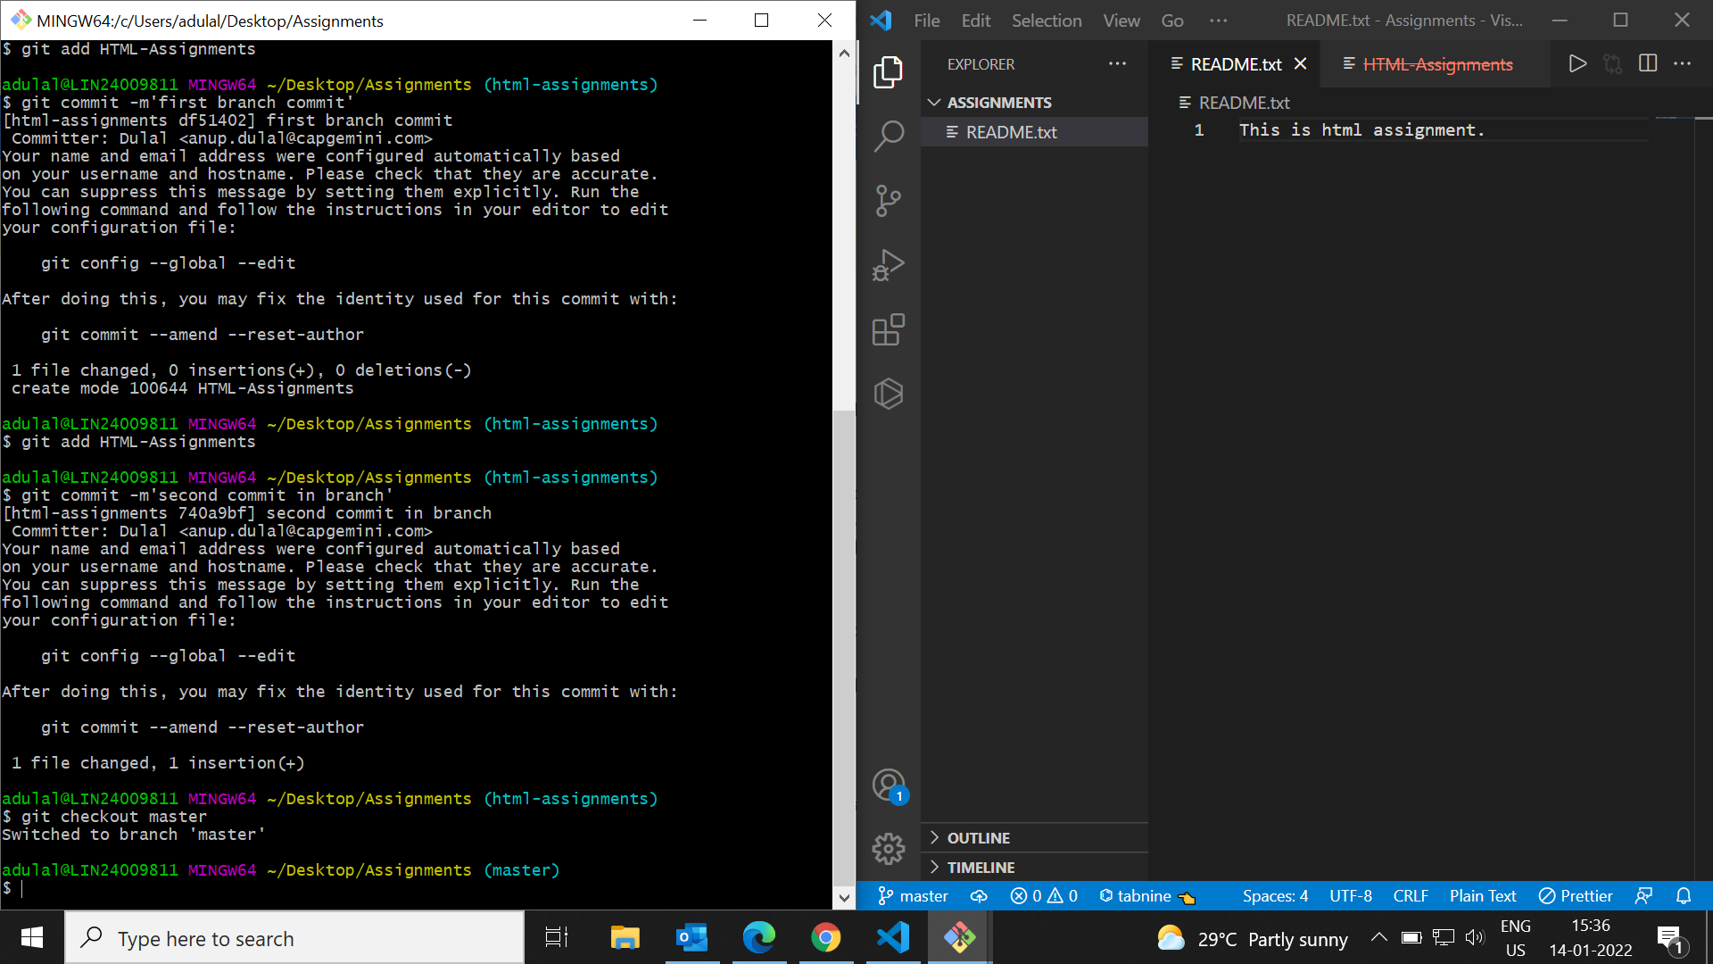

Figure : Edited and commited on branch and checkout to the master branch

Figure : Delete the branch

Figure : Merge both master and html-assignment branch

Figure : edit and commit README.txt in css-assignment

Figure : Created css-assignment branch and created a CSS-Assignment file

Figure : Creating Js-assignment branch and created js-assignment file

Figure : Merge conflict while merging

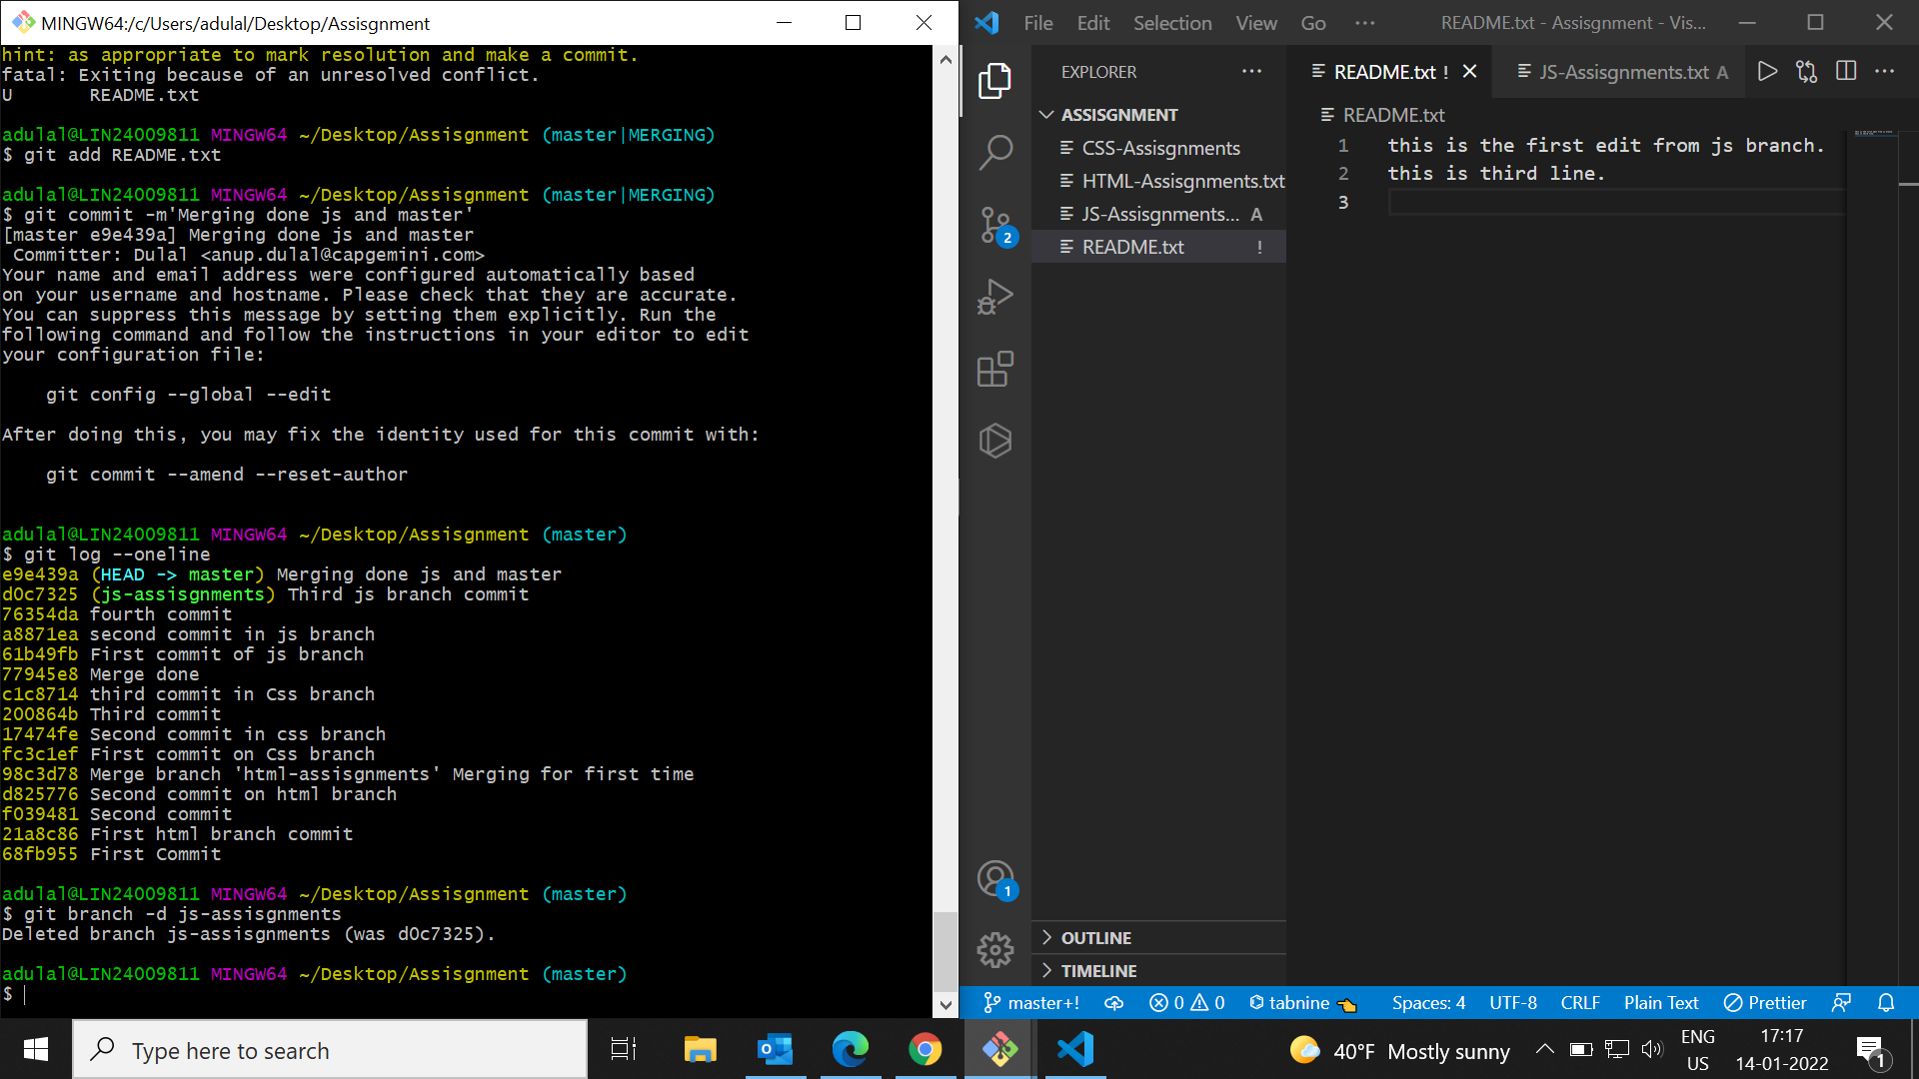

Figure : Editing, merging and deleting of the branch